**Module A.4 Computing History**

Level 0: Personal Computer Internals

1. Fan inside of a computer Power supply and fan of a computer Connectors

and expansion

slots

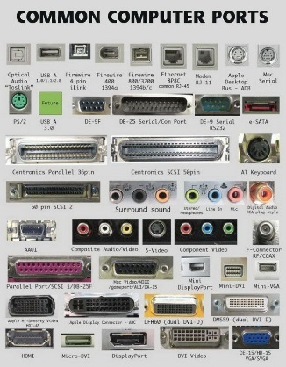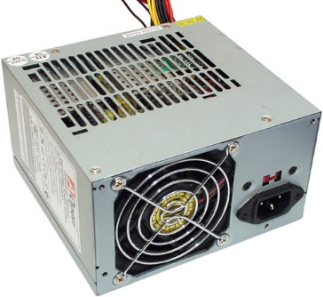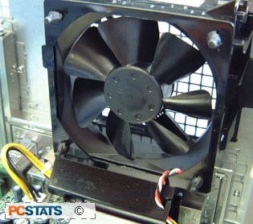

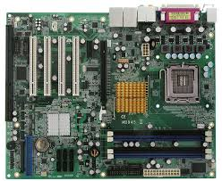 Motherboard of a computer

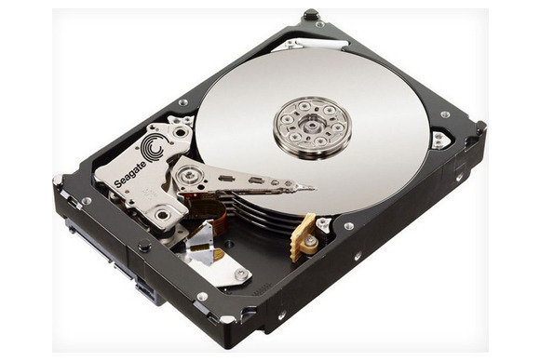 Hard disk drive of a computer

optical drive of a computer

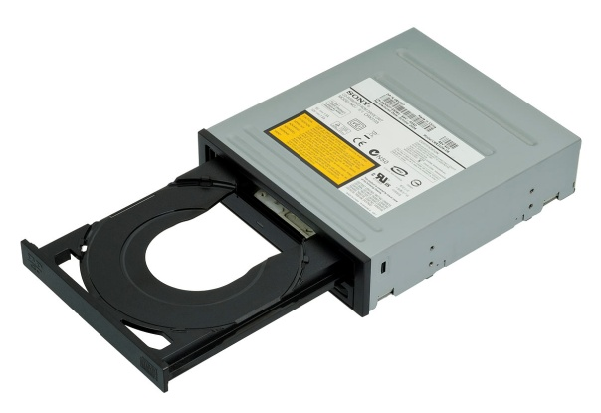

**Level 1:History of computers**

**1) a./b.** IBM developed its first mainframe computer, known as the Automatic Sequence Controlled Calculator (ASCC), in 1944. It solved addition and multiplication problems in less than six seconds. The ASCC was operated by a system of thousands of vacuum tubes.

**2) a.** Supercomputers were introduced in the 1960s, and for several decades the fastest were made by Seymour Cray at Control Data Corporation (CDC), Cray Research and subsequent companies bearing his name or monogram.

**b.** Deep Blue was a [chess-playing computer](https://en.wikipedia.org/wiki/Computer_chess) developed by [IBM](https://en.wikipedia.org/wiki/IBM). It is known for being the first computer chess-playing system to win both a chess game and a chess match against a reigning world champion under regular time controls.

**c.** Quantum computing often grabs the headlines. The word "quantum" itself is intriguing enough, and combined with the promise of computational power that surpasses anything we have seen so far it becomes irresistible. But what exactly is quantum computing

**3) a.** The IBM Personal Computer, commonly known as the IBM PC, is the original version and progenitor of the compatible hardware [platform](https://en.wikipedia.org/wiki/Platform_(computing)). It is [IBM](https://en.wikipedia.org/wiki/IBM) model number 5150, and was introduced on August 12, 1981.

**b.** The first personal computers, introduced in 1975, came as kits: The MITS Altair 8800, followed by the IMSAI 8080, an Altair clone.

**c.** Apple Computer 1, also known later as the Apple I, or Apple-1, is a [desktop computer](https://en.wikipedia.org/wiki/Desktop_computer) released by the Apple Computer Company (now [Apple Inc.](https://en.wikipedia.org/wiki/Apple_Inc.)) in 1976, It was designed and [hand-built](https://en.wikipedia.org/wiki/Handicraft) by [Steve Wozniak](https://en.wikipedia.org/wiki/Steve_Wozniak).

**d.** The first era of PCs was from 1940 to 1955. PCs were controlled by vacuum tubes and utilized attractive drums to store information and memory. At that point in 1956, the second era of PCs hit. The vacuum tubes were never again the best thing for running a PC, the most recent segment to supplant the vacuum tubes is a transistor. The time of transistors was brief on the grounds that in 1964, coordinated circuits turned into the following incredible thing in creating semiconductor innovation. The fourth era is as yet the present era of PCs. At the point when microchips where imagined in 1971, the period of mass use of PCs started. As time has gone on, PCs have dramatically affected the way we think and work. Before the first PC was imagined, "PC" was an expected set of responsibilities for individuals who performed figuring’s by hand and paper, and now those sets of expectations have changed to Web optimization

**Level 2: History of Computer Components**

**1) a.** The Intel 4004 is a 4-bit central processing unit (CPU) released by Intel Corporation in 1971. It was the first commercially available microprocessor by Intel. The chip design started in April 1970, when Federico Faggin joined Intel, and it was completed under his leadership in January 1971.

**b.** An electronic circuit formed on a small piece of semiconducting material, performing the same function as a larger circuit made from discrete components.

**c.** Today the CPU is the cornerstone of millions of computers across the globe, but it was not always the case that computers had a CPU. The first modern [CPU](http://www.brighthub.com/computing/windows-platform/articles/4759.aspx) was built under a name that everyone today recognizes - Intel "The Intel 4004". In 1978 Intel released the Intel 8086. It was released under some pressure, as competitors were already pushing out 16-bit design and some 32-bit designs were right around the corner. At the time Intel had no 16-bit processor. The 1990s were largely a period where competition consisted of increasing clock speeds and larger cache sizes.

**2) a.** Ram memory is a form of [computer data storage](https://en.wikipedia.org/wiki/Computer_data_storage) which stores frequently used program instructions to increase the general speed of a system and Core memory was a common form of random access memory (RAM) from the mid-1950s to the mid-'70s, and It was developed at MIT in 1951.

**b**. Moore's law refers to an observation made by Intel co-founder Gordon Moore in 1965. He noticed that the number of transistors per square inch on integrated circuits had doubled every year since their invention. Moore's law predicts that this trend will continue into the foreseeable future.

**c.** Ram has evolved by replacing older vacuum tubes and magnetic cores to enable motherboard development and eventually allowing computers as we know them today to develop.

**d.** Computers have two kinds of storage- temporary and permanent. A computer’s **memory** is used for **temporary** storage, while a computer’s **hard drive** is used for **permanent** storage.

**3) a.** VGA  is the display hardware first introduced with the IBM PS/2 line of computers in 1987. Through widespread adoption, the term has also come to mean either an analog computer display standard, the 15-pin D-subminiature VGA connector, or the 640×480 resolution characteristic of the VGA hardware.

1. 9 pin D-subminiature
2. Nvidia g-force 256 in 1995
3. 1981-IBM monochrome disply adapter, 1983- intel isbx 275 vgcmb, 1988-ati vga wonder, 1996- 3efx voodoo 1, 1997- Nvidia riva 128, 1998- 3dfx voodoo 2, 1999- Nvidia GeForce 256 ddr, 2002- ati radeon 9700, 2006- Nvidia GeForce 8800gtx, 2009- ati radeon hd 5970, 2009- Nvidia geforce gtx 295, 2012- amd radeon hd 7970, 2012- Nvidia geforcec gtx 680, 2013- amd radeon r9 290, 2014- Nvidia geforce gtx 970, 2016- amd radeon rx 480, 2106- Nvidia geforce gtx 1080